ACTIVE DIRECTORY
DOMAIN SETUP
Configuring a domain controller and joining a Windows client
A practical home-lab case study documenting the setup, configuration and verification of a small Windows domain environment.
PROJECT TYPE | Personal IT home lab
TECHNOLOGIES | Windows Server • Active Directory Domain Services (AD DS) • DNS • Windows 11 Pro VM
DOMAIN | darshanhome.local

1. Project Objective
The objective was to create a small Windows domain environment to practise centralised identity management, DNS configuration and domain joining a Windows client.

2. Lab Environment
Component | Role | Configuration / Notes
Windows Server | Domain controller / DNS | Server name:WIN-4T7LA5PFRV6  OS version: Windows Server 2022  IP address : 192.168.1.16
Windows 11 Pro VM | Domain client | VM name:Windows 11*64  network mode:NAT
Active Directory | Identity and domain management | darshanhome.local

3. Implementation Steps

Step 1 — Configure the server
The server was assigned a suitable computer name. Afterwards, a static IPv4 address was configured to ensure that the server maintained a consistent IP address.
A static IP address is important for a domain controller because client computers rely on it to locate domain services and communicate with the DNS server.

Figure 1: Windows Server Properties

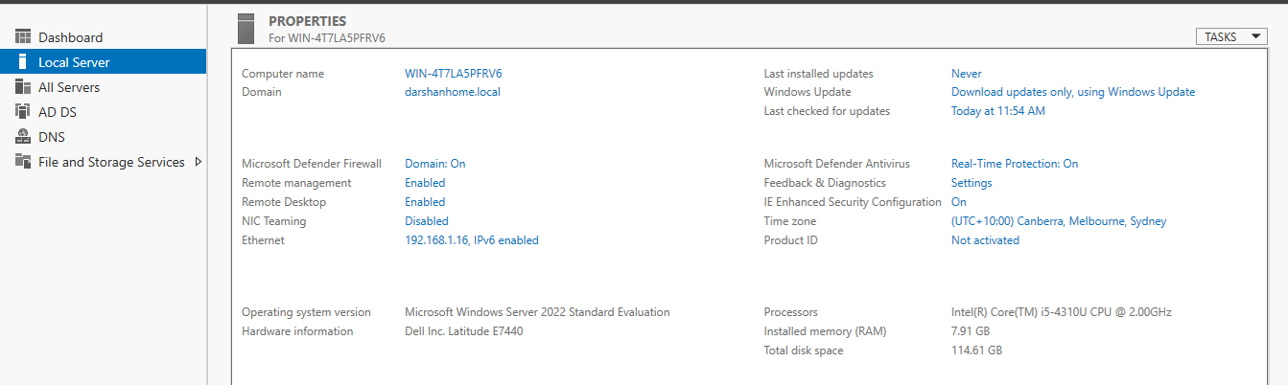
What this screenshot proves:
This screenshot shows the Windows Server 2022 environment, including the computer name, domain name (darshanhome.local), and current network IP address. It provides an overview of the server prepared for the Active Directory home lab.
Figure 2: Static IP Configuration
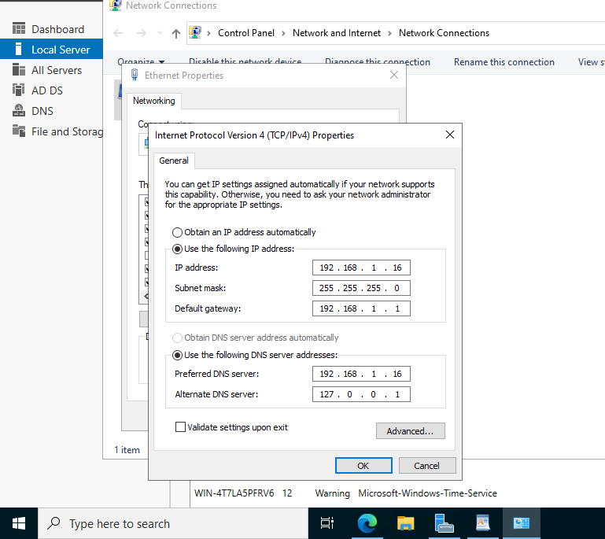
What this screenshot proves: Shows the server's IPv4 address, subnet mask and default gateway.

Figure 3: Verification of the Windows Server network configuration using ipconfig /all

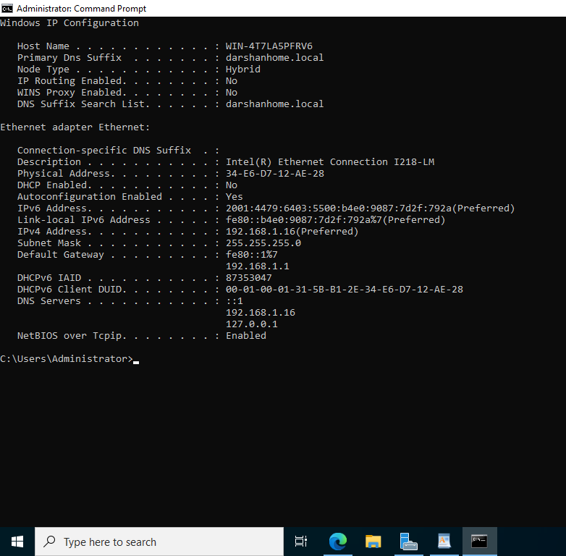
What this screenshot proves:
The ipconfig /all command was used to verify the server's network configuration, including its hostname, IPv4 address, subnet mask, default gateway and DNS server settings. This information helped confirm that the server was configured correctly for the Active Directory environment.
The server's preferred DNS server was configured to use its own IP address, allowing it to use the DNS service hosted on the domain controller.

Step 2 — Install and configure AD DS

- I installed the Active Directory Domain Services (AD DS) role using Server Manager on Windows Server.
- After the installation was completed, I used the Active Directory Domain Services Configuration Wizard to promote the server to a domain controller.
- During the configuration process, I created a new forest with the domain name darshanhome.local and configured the required domain controller settings.
- Once the configuration was completed, the server restarted to apply the changes.
- This configuration established the Active Directory domain environment, allowing me to centrally manage domain user accounts, computer objects, authentication and Group Policy settings in my home lab.

Figure 4: Active Directory domain structure showing the domain and organizational units (OUs).
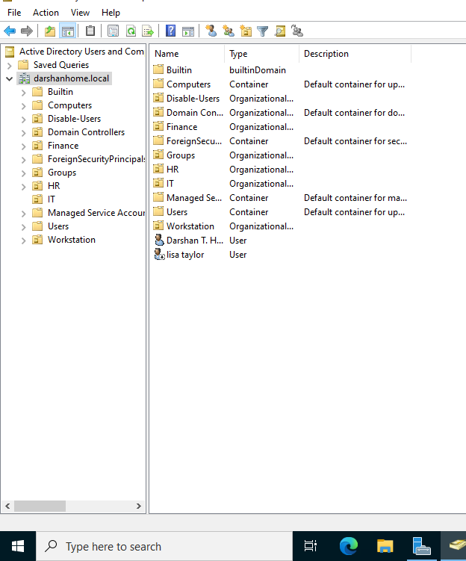

Step 3 — Configure DNS

DNS (Domain Name System) is essential for Active Directory because it allows domain-joined computers to locate domain controllers and other domain services.
In my home lab, I configured the Windows Server to use its own static IP address as its preferred DNS server. The server hosts the DNS service for the darshanhome.local domain.
I then configured the Windows client VM to use the domain controller's IP address as its preferred DNS server. This allows the client to resolve internal domain names and locate the domain controller during domain authentication.
I verified the network and DNS configuration using the ipconfig /all command.
Figure 5: Server Network Configuration Using ipconfig /all
What this screenshot proves: Verification of the server's IPv4 and preferred DNS server configuration.

Step 4 — Join the Windows Client to the Domain

I prepared the Windows 11 Pro virtual machine for integration into my Active Directory environment. After configuring the client’s network settings to use the domain controller for DNS, I joined the computer to the darshanhome.local domain.
After completing the domain-joining process, I restarted the virtual machine to apply the changes. This allowed the client to participate in the domain environment and use centralised domain authentication.
I subsequently verified the domain configuration using Active Directory and network troubleshooting tools.
Figure 6: Verification of Windows 11 Client Domain Membership
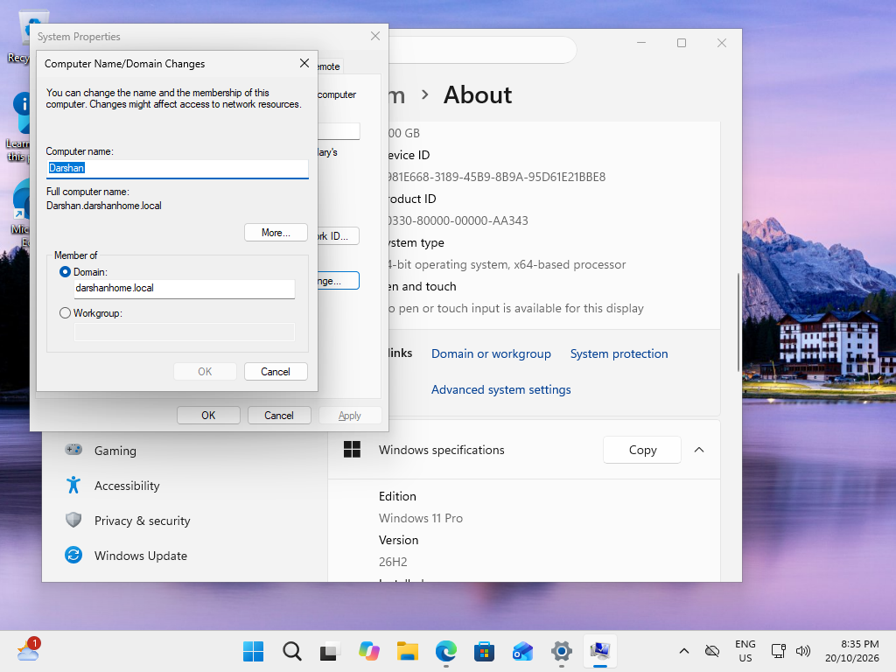
What this screenshot proves: Verification of Windows 11 client membership in the darshanhome.local domain.

Step 5 — Verify the configuration

After configuring Active Directory Domain Services and DNS, I performed several checks to verify the domain configuration and connectivity between the Windows client and the domain controller.
I used the nslookup command to examine DNS resolution for the domain and identify the DNS server responding to the query. I also used nltest /dsgetdc:darshanhome.local to check whether the client could discover a domain controller for the domain.
These checks helped me validate DNS functionality and domain controller discovery within my home lab environment.
Figure 7: DNS Resolution Test Using nslookup and Domain Controller Discovery Test Using nltest
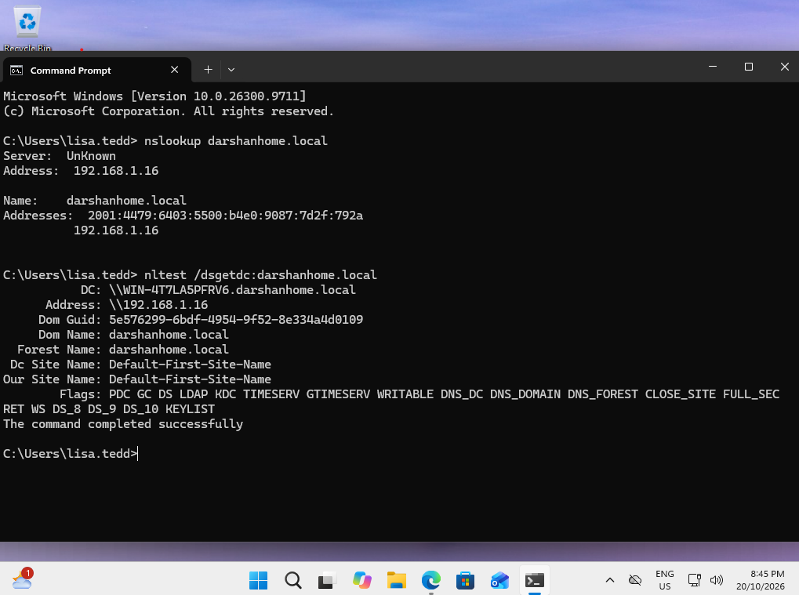

4. Troubleshooting Notes
Symptom / Error | Investigation | Resolution / Outcome
The Windows client encountered errors while attempting to join the darshanhome.local domain. The errors included Status 1355 and 1212, preventing the domain-joining process from completing successfully. | I investigated the client’s network configuration, DNS settings and time configuration. I checked the IPv4 address, default gateway and preferred DNS server using ipconfig /all. I also investigated whether the client could locate the domain controller and whether the system time and time zone were configured correctly. | I corrected the relevant configuration issues identified during troubleshooting, including the DNS and time-zone settings. After making the corrections, I retried the domain-joining process and successfully connected the Windows client to the darshanhome.local domain.

5. Testing and Results
☐ Confirmed the client is joined to the intended domain.
Test performed: Checked the Windows 11 Pro client's domain membership.
Result: Successful. The client was joined to the darshanhome.local domain.
Evidence: System Properties showing the domain membership.

☐ Confirmed the client can discover a domain controller.
Test performed: Executed nltest /dsgetdc:darshanhome.local on the client.
Result: [Record whether the command successfully discovered the domain controller.]
Evidence: Command Prompt output showing the discovered domain controller.

☐ Confirmed DNS resolves the relevant domain records as expected.
Test performed: Executed nslookup darshanhome.local to check DNS resolution.
Result: [Record the DNS response and whether the lookup succeeded.]
Evidence: Command Prompt output showing the DNS server and query response.

☐ Recorded any remaining limitations or issues.
Result: No additional issues were identified during the checks performed, apart from any limitations or errors documented in the troubleshooting section.
Note: Update this statement if any tests remain incomplete or issues are still unresolved.

6. Key Skills Demonstrated
6. Key Skills Demonstrated
- Active Directory Domain Services (AD DS) fundamentals
- DNS configuration and resolution
- Windows domain joining and domain membership verification
- Client/server network configuration and connectivity
- Domain controller discovery using nltest
- DNS troubleshooting using nslookup
- Basic Windows troubleshooting and problem-solving
- Technical documentation and screenshot-based evidence

7. What I Learned
Through this project, I gained practical experience configuring Active Directory Domain Services, setting up DNS and joining a Windows 11 client to a domain. I developed my troubleshooting skills by investigating domain joining errors and identifying a time zone configuration issue that needed to be corrected. In future projects, I would improve my documentation by capturing screenshots at each stage of the configuration process and recording the results of each test.

8. Project Summary
Successfully configured an Active Directory home lab using Windows Server and the darshanhome.local domain. Joined a Windows 11 Pro client to the domain and practised configuring DNS, verifying domain controller discovery and troubleshooting domain-joining issues. This project provided practical experience in Windows domain administration, network configuration and systematic IT troubleshooting.

LinkedIn portfolio note: This document describes a personal home-lab project, not production enterprise administration.

